[[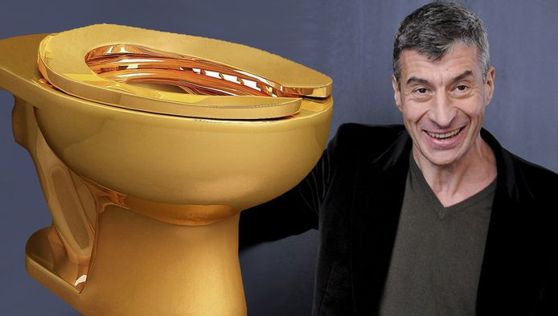](https://www.ad.nl/home/museum-plaatst-massief-gouden-toilet-van-cattelan~a5bf6c03/65602869/)](https://www.ad.nl/home/museum-plaatst-massief-gouden-toilet-van-cattelan~a5bf6c03/65602869/)

Maurizio Cattelan en zijn gouden toiletpot © EPA/Maurizio Cattelan

**Museum plaatst massief gouden toilet van Cattelan**

**De Italiaanse kunstenaar Maurizio Cattelan, een van de best betaalde ter wereld en in 2011 gestopt omdat hij de kunstwereld zat was, is terug. Het Guggenheimmuseum in Manhattan gaat in mei zijn nieuwste werk plaatsen: een massief, 18-karaats gouden toilet naar een oorspronkelijk ontwerp van wc-fabrikant Kohler.**

**Bron:** ANP

De kostbare wc-pot wordt volgens de New York Times niet achter glas tentoongesteld op zaal maar komt als gebruiksvoorwerp te staan in een publieke ruimte met stenen soortgenoten, spiegels, wasbakken en deuren met een slot.  
  
**Koesteren in de glans**  
Voor wie behoefte voelt. ,,Je kunt naar die sanitaire voorziening gaan om je te koesteren in de glans ervan, maar het wordt pas kunst als iemand erop zit of erover heen hangt'', aldus Cattelan.  
  
De aankondiging van de aanwinst van het [Amerikaanse museum](http://www.guggenheim.org/new-york/exhibitions/past/exhibit/3961), waar ooit ook een drol van de artiest in een blikje werd geëxposeerd, hield de gemoederen woensdag aardig bezig. Kenners roemden het werk als een schitterend symbool voor de obscene rijkdom in de kunst in combinatie met een werkende vergaarbak van menselijke uitwerpselen.

The stolen golden toilet: the perfect punchline to an 18-carat joke

Maurizio Cattelan is right to enjoy the loss of his fully-functioning conceptual wonder. It makes his comment on art, money and Trumpian desire even more briljant

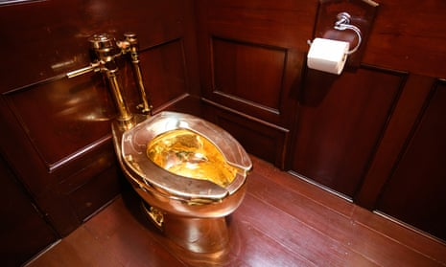A load of bullion … America at Blenheim Palace before it disappeared. Photograph: Leon Neal/Getty Images

Mon 16 Sep 2019 14.51 BST

It feels like a huge honour to have been, quite possibly, one of the last people to pee in [Maurizio Cattelan](https://www.theguardian.com/artanddesign/maurizio-cattelan)’s golden toilet. If his artwork, the solid gold lav stolen from Blenheim Palace on Friday night, is not recovered soon, it may never be seen again. For it seems unlikely this crime was commissioned by an anally obsessed collector or planned by gangsters to use the loo as underworld collateral. “Don Corleone, to mark our deal, please accept this golden toilet.” Let’s face it, the thieves stole Cattelan’s conceptual wonder for the metal it is made of.

If so, a few molecules of my urine may be mixed into the ingots it becomes. I used Cattelan’s toilet while reviewing his exhibition at Blenheim Palace last Thursday morning. I wasn’t originally going to put the loo to practical use, but then I thought, why not? It was plumbed into a small wood-panelled bathroom with the lock removed. You had to rely on the attendant outside to maintain your privacy. Being alone with it was a meditative, almost philosophical moment. (Isn’t it always?) Yet as I flushed it felt banal and ordinary. You can’t gild bodily waste. Which is Cattelan’s point.

I usually find art thefts upsetting, but it’s hard not to laugh at this one. The artist himself congratulated the thieves and praised their feat as performance art – before being forced to deny [orchestrating it as a prank](https://www.theguardian.com/artanddesign/2019/sep/15/artist-pans-claims-he-orchestrated-theft-of-solid-gold-toilet). But this is no clever stunt. Its beauty lies in its stupidity. Blenheim’s aristocratic owners, like other members of high society, are au fait with contemporary art and by plumbing Cattelan’s toilet into their stately pile were being clever and flip with their family heritage – even pointedly situating it next to the room where Winston Churchill was born. But all the thieves appear to have heard was the word “gold”. This is more bullion raid than art theft. As such, it wonderfully continues the joke Cattelan played on the art world when he created this piece in 2016.

When Cattelan had this golden throne fabricated, called it America and plumbed it in at [New York’s Guggenheim Museum in 2016](https://www.theguardian.com/artanddesign/2016/sep/16/gold-toilet-guggenheim-america-maurizio-cattelan), he was taking a dump on the modern art market. Back in 1917, the French artist [Marcel Duchamp showed a porcelain urinal](https://www.theguardian.com/books/2008/feb/09/art) in a New York art exhibition. How far has art come in the century since? Intellectually and creatively, Cattelan’s loo implies, nowhere at all. The fact that 100,000 people queued to use his lavatory proves that we are still locked into the same simple gestures that worked in 1917. The shock of the new has become the repetition of the pseudo-new. Yet while Fountain was considered so financially worthless that Duchamp’s friend Alfred Stieglitz simply threw it away, Cattelan’s gold loo is an image of an art world that now takes the Dada gestures of a century ago and turns them into commodities worth millions.

Cattelan’s artwork wees on the hand that feeds him. It is a magnificent gesture of contempt for money. Its title, America, is another Duchamp echo: “What has America given if not its plumbing?” asked the Frenchman who, coming from the land of the *pissoir*, clearly found US hygiene obsessions absurd. But it replaces Duchamp’s measured irony with a more brutal sneer. America is the land where money can buy you anything. The work’s installation in New York coincided with the election that brought gold-adoring [Donald Trump](https://www.theguardian.com/us-news/donaldtrump) to the White House – and Guggenheim curator Nancy Spector satirically offered America to the president. But even Trump’s people could see the satire. A gold lavatory is a futile attempt to pretend our bodies are able to do something other than eat, defecate and die.

Once, when criticising the Vatican’s wealth, [Pope John Paul I confessed that his toilet flush handle was made of solid gold](https://www.opednews.com/articles/The-Vatican-s-Golden-Toile-by-Rev-Dan-Vojir-130128-722.html) and studded with diamonds. Cattelan, whose image of John Paul II crushed by a meteor is also in his Blenheim exhibition, may have had such tales of papal toilet splendour at the back of his mind when he came up with America. The exhibition climaxes with a miniature Sistine Chapel, which reveals the love-hate relationship with Christianity at the heart of his work.

One place where we come face to face with our fragile physical nature is on the toilet. But gold is an image of immortality. It was sought by medieval alchemists because they believed it was “incorruptible”. A gold toilet is one that promises eternal life.

The artist is right to enjoy his most notorious art work being stolen. It’s a great punchline to his bitter joke about art, money and the [Trumpian desire to purchase not just Greenland](https://www.theguardian.com/commentisfree/2019/aug/21/trump-wanting-to-buy-greenland-is-yet-another-sign-of-putins-puppetry), but immortality itself. The magic values the art world attaches to conceptual art are comically reduced by this heist to the price of its materials – even though, melted down, it would be “worth” less than it might fetch in an art auction. Refined contemporary art lovers have found themselves shat on by criminals who simply saw this “work of art” as a quantity of gold. They’re the real critics – they saw the bullion behind the bullshit.